Requirements Specification

Table of Contents

[Aims and Objectives: 2](#_Toc470009524)

[Target Audience 2](#_Toc470009525)

[Technical Requirements 3](#_Toc470009526)

[Client requirements 3](#_Toc470009527)

[Functional Requirements 4](#_Toc470009528)

[Non Functional requirements 4](#_Toc470009529)

[Accessibility Requirements 5](#_Toc470009530)

[Usability Requirements 5](#_Toc470009531)

[Storyboards (for each page) 6](#_Toc470009532)

[Navigation map 7](#_Toc470009533)

[Test log 7](#_Toc470009534)

[How you validate your Website: 8](#_Toc470009535)

[Evaluation 8](#_Toc470009536)

# Aims and Objectives:

**(Why you need this website, what you want to achieve)**

**To explain people voluntary retribution needs. Collect donations from people and keep this data in SQL database. Collect the personal data from people who make contributions and keep this information in database.**

# Target Audience

**(Who will use this website?)**

**Wide range of people.**

# Technical Requirements

*Web development*

*(What software and hardware involved? What skills and resources involved)*

*Web page should be accessible from any web browser. Page should be displayed on the most screen resolution.*

# Client requirements

*(General requirement gathering from client: e.g. welcome message, logo, image, fixed navigation bar, donation method, map, contact information….)*

*Home page should contain welcome message and give the possibility to get on registration page or “donate” page also should give a possibility to Sign in for the people who already registered.*

# Functional Requirements

**(What you website can do, e.g. register, login, donate)**

**Register, login, donate, read charity information.**

# Non Functional requirements

**(Deadline, budget, role & responsibility or anything not relevant to your website really “can do”.)**

**Parse NULL as user id when an anonymous user donates. Developed for charity with no profits or salary paid to the developer (Vladimir Yesipov).**

# Accessibility Requirements

**(Web safe color, image alter, Fonts and colors, easily readable, clear and simple UI)**

**Simple and intuitive UI. Alt attribute used for images to improve accessability.**

# Usability Requirements

(Easy to use, User friendly, Mobile friendly, Minimize scripts, Efficiency of use, Intuitiveness,)

Minimum scripts. Navigation panel on each page. Responsible layout applied.

# Storyboard (for the front page)

|  |  |  |
| --- | --- | --- |
| **Name: Vladimir Yesipov** | **Project: Good Gym data driven web** | **Screen: index.html** |

|  |
| --- |
| **C:\Users\vladi\AppData\Local\Microsoft\Windows\INetCache\Content.Word\front_page.jpg**  **Interactivity:**  **Internal links to every page plus login button which displays login form for registered user. External link to developer website.** |

|  |
| --- |
| **Outline of page**  This page designed to introduce Good Gym charity to user and navigate across the web site. |

|  |
| --- |
| **Style guide**  **../css/style.css** |

|  |  |
| --- | --- |
| **Media elements** | **File type** |
| **Media name:**  **logo** | **Media type:**  **png** |
| **Media name:**  **carousel** | **Media type:**  **jpg** |
| **Media name:**  **charity** | **Media type:**  **jpg** |
| **Media name:**  **Img\_avatar2** | **Media type:**  **png** |
|  |  |

# Storyboard (for the registration page)

|  |  |  |
| --- | --- | --- |
| **Name: Vladimir Yesipov** | **Project: Good Gym data driven web** | **Screen: register.html** |

|  |
| --- |
| **C:\Users\vladi\AppData\Local\Microsoft\Windows\INetCache\Content.Word\register_page.jpg**  **Interactivity:**  **Internal links to every page plus login button which displays login form for registered user. External link to developer website.** |

|  |
| --- |
| **Outline of page**  This page designed to provide a registration form for new user. |

|  |
| --- |
| **Style guide**  **../css/style.css** |

|  |  |
| --- | --- |
| **Media elements** | **File type** |
| **Media name:**  **Img\_avatar2** | **Media type:**  **png** |
| **Media name:**  **logo** | **Media type:**  **png** |
|  |  |
|  |  |

# Storyboards (for donation page)

|  |  |  |
| --- | --- | --- |
| **Name: Vladimir Yesipov** | **Project: Good Gym data driven web** | **Screen: donation.html** |

|  |
| --- |
| **Outline of page**  This page designed to provide a donation form for a user. |

|  |
| --- |
| **C:\Users\vladi\AppData\Local\Microsoft\Windows\INetCache\Content.Word\donate_page.jpg**  **Interactivity:**  **Internal links to every page, donation form submission button plus login button which displays login form for registered user. External link to developer website.** |

|  |
| --- |
| **Style guide**  **../css/style.css** |

|  |  |
| --- | --- |
| **Media elements** | **File type** |
| **Media name:**  **logo** | **Media type:**  **png** |
| **Media name:**  **charity** | **Media type:**  **jpg** |
| **Media name:**  **Img\_avatar2** | **Media type:**  **png** |
|  |  |

# Navigation map

(How you pages are linked together? How to navigate from one page to another)

|  |
| --- |
| **Navigation bar under the company logo.** |

# Test log

Testing a website is essential to ensure:

1. All hyperlinks work correctly
2. pictures display clearly
3. there is no spelling or grammar errors.
4. Different devices are able to correctly display a website

**Test Plan**

|  |  |  |  |
| --- | --- | --- | --- |
| **Test** | **Expected Output** | **Actual Output** | **Comment** |
| **1** | **Displays all pages correctly** | **Displays all pages** |  |
| **2** | **Login button changes the title after user logged in on user email** | **Pass** |  |
| **3** | **Donation page supposed to show logged in user name and surname** | **Pass** |  |
| **4** | **Login modal form called after pressing login button** | **Login modal form called after pressing login button** |  |
| **5** | **Login modal can be closed by pressing cancel button or by clicking x button at the top right corner** | **Pass** |  |
| **6** | **Registration form parses the values into the SQL table** | **Pass** |  |
| **7** | **Donation form parses the values into the SQL table** | **Pass** |  |
| **8** | **All images are shown properly and look aesthetic** | **Pass** |  |
| **9** | **Navigation bar works correctly** | **Pass** |  |
| **10** | **Web page reacts on the screen size change** | **Pass** |  |
|  |  |  |  |

# How you validate your Website:

|  |
| --- |
| **W3C validator.** |

**Validation Screen shot (every page) no error, but warning acceptable:**

**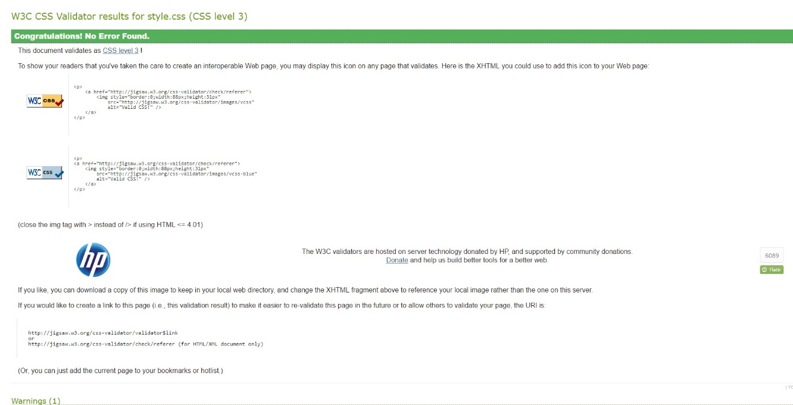**

**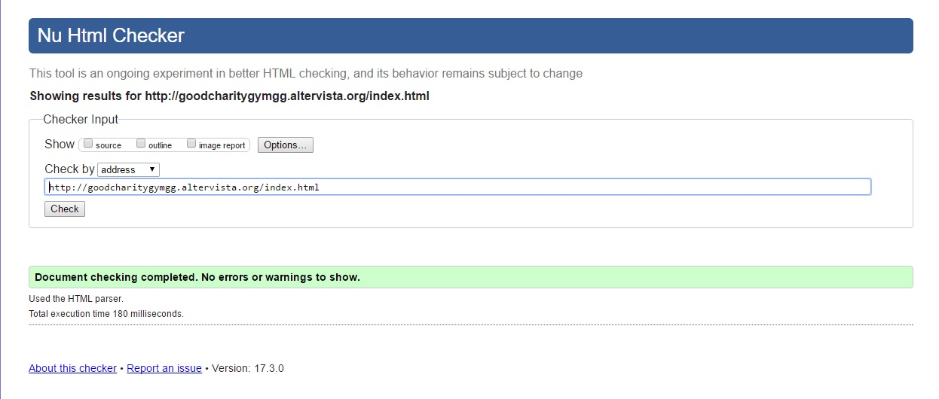**

**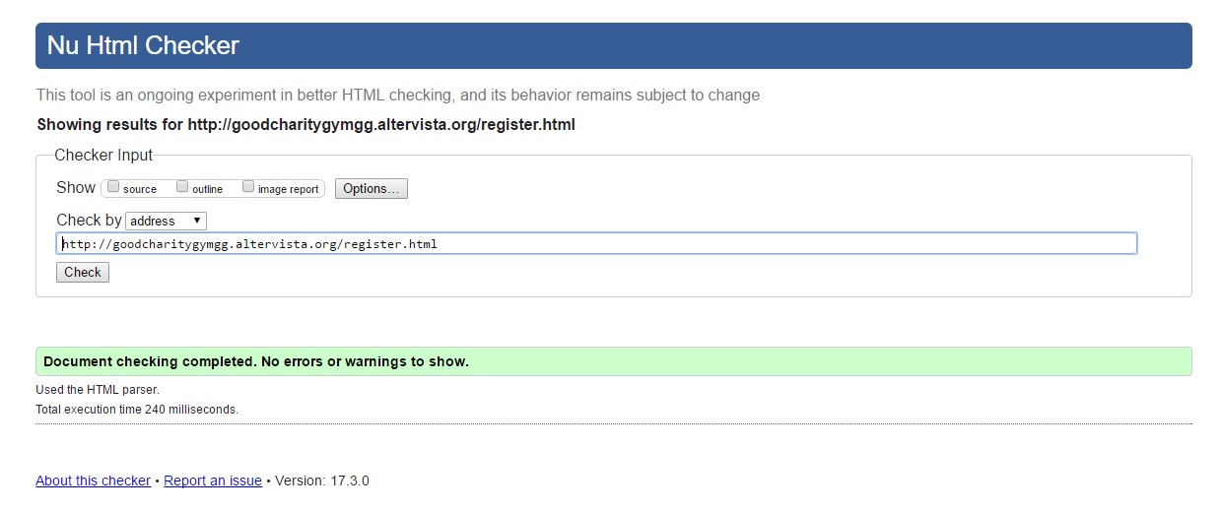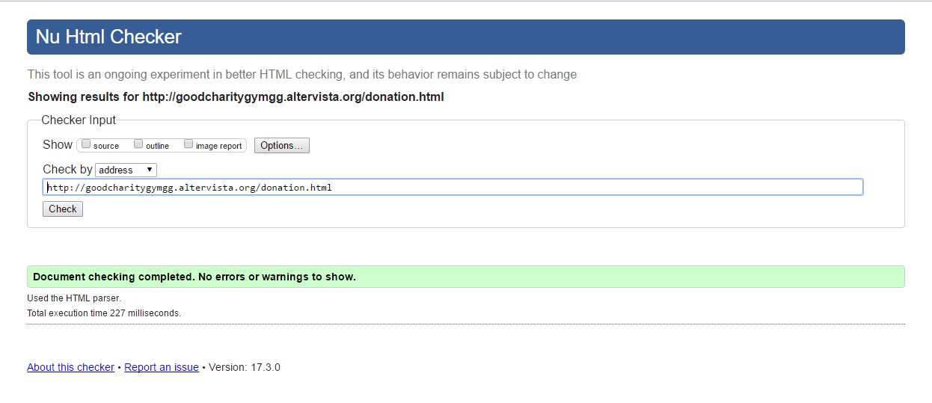**

****

# Evaluation

Effective use of Markup Language (Good markup practise e.g. comments, white space and so on)

|  |
| --- |
| **Had not enough time to fix validation of html code. Because only html files can be validated through w3c validator and the files with php code should be named as php files. Trying to do a lot on my web to get a website functionality as better as possible because have no experience in developing websites and the needs (what exactly must be done) of the project are not clear for me (which part is necessary and which part could be skipped). Spend a lot of time on googling the problems I had and still have. Altervista web page given for testing is not very useful as I should clear the cache every time I make changes and login again to do the test again even thou clearing the cache not working every time to see changes made.**  **Still not sure what exactly should be in a html file and what exactly should be in php because most modern websites are made in php and these php have html inside.**  **My php codes working fine I see that I can login, logout, register new user and do a donation pay. All internal links are working. Only one external link I have which supposed to direct user onto the developer site which doesn’t exist.**  **JavaScript validator gen\_validatorv4.js from** <http://www.javascript-coder.com/html-form/javascript-form-validation.phtml> **does not pass w3c validator need to replace with the one that will or make one by myself.** |